**CS 557 Winter 2018**

Project 1: Elliptical Dots

Benjamin Fields

fieldsbe@oregonstate.edu

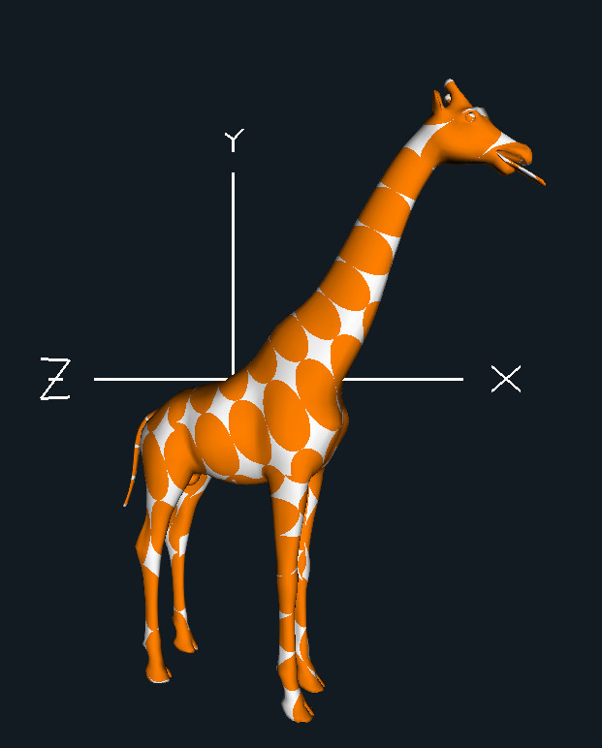

**Figure 1:** Screenshot from the program. Video can be found at the following link:

https://media.oregonstate.edu/media/t/0_5s8bjhch